**Practical – 1**

**Aim:**

**Output:**

1. **Input String : bbbb**



1. **Input String : aaa**



1. **Input String : baaabb**



1. **Input String : aaaaabb**



1. **Input String : abb**



**Conclusion:**

**Practical – 2**

**Aim:**

**Output:**

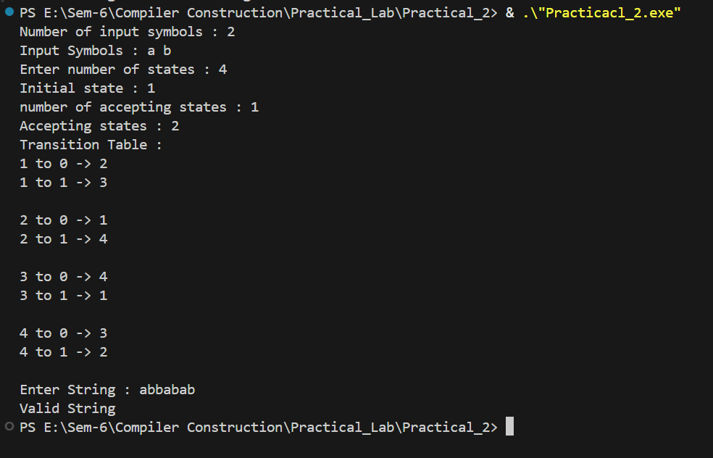

**Conclusion:**

**Practical – 3**

**Aim:**

**Output:**

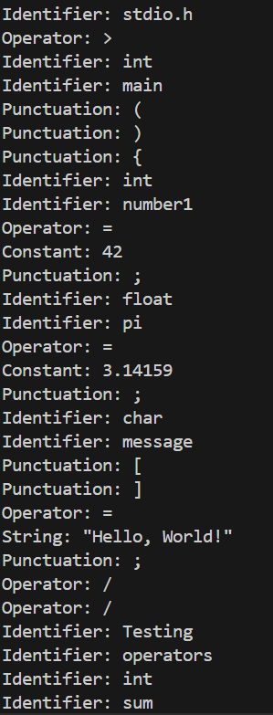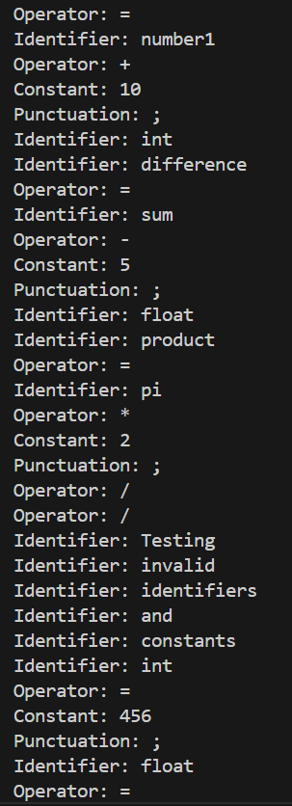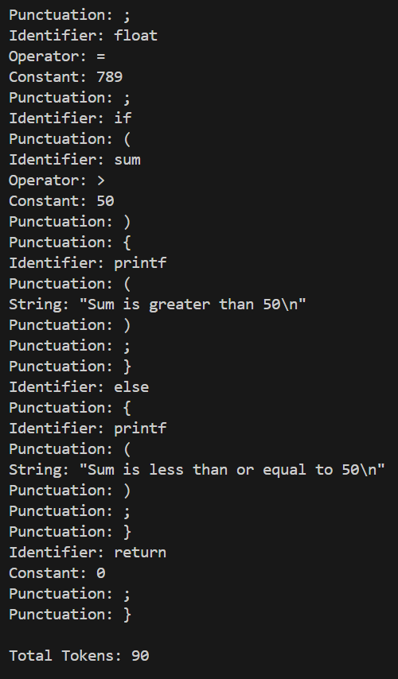

**Conclusion:**

**Practical – 4**

**Aim:**

**Output:**

1. **Objective 1:**

* **Input String: a1b22c3**

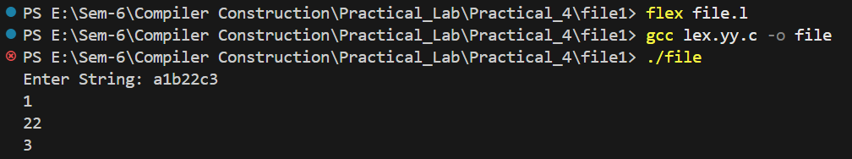

* **Input String: power operation -> 12 ** 3 = 1728**

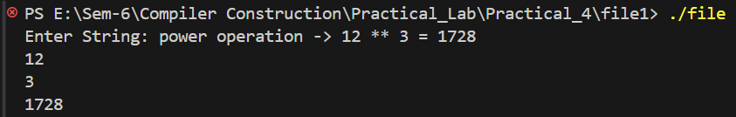

* **Input String: You multiply 804569 with 1 then will be :**

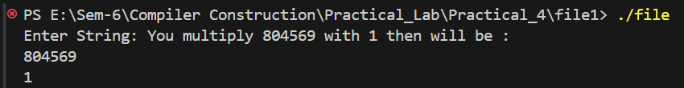

1. **Objective 2:**

* **Input String: This is charusat.**

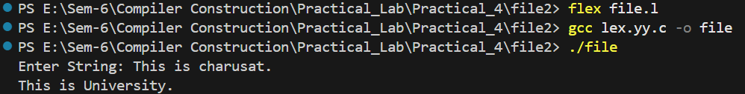

* **Input String: Charusat is in Anand district.**



* **Input String: Charusat , What is charusat?**



1. **Objective 3:**

* **Input String: This is charusat.**

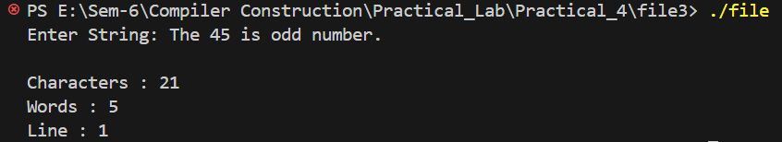

* **Input String: This is charusat.**

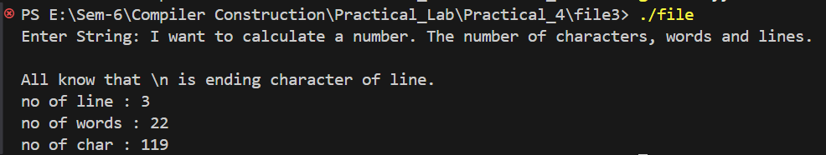

* **Input String: This is charusat.**

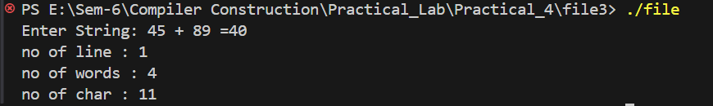

1. **Objective 4:**

* **Input String: a@IT**



* **Input String: Charusat@2024**



* **Input String: Charu$at@20#24**



* **Input String: charu*sAT;22**



**Conclusion:**

**Practical – 5**

**Aim:**

**Output:**

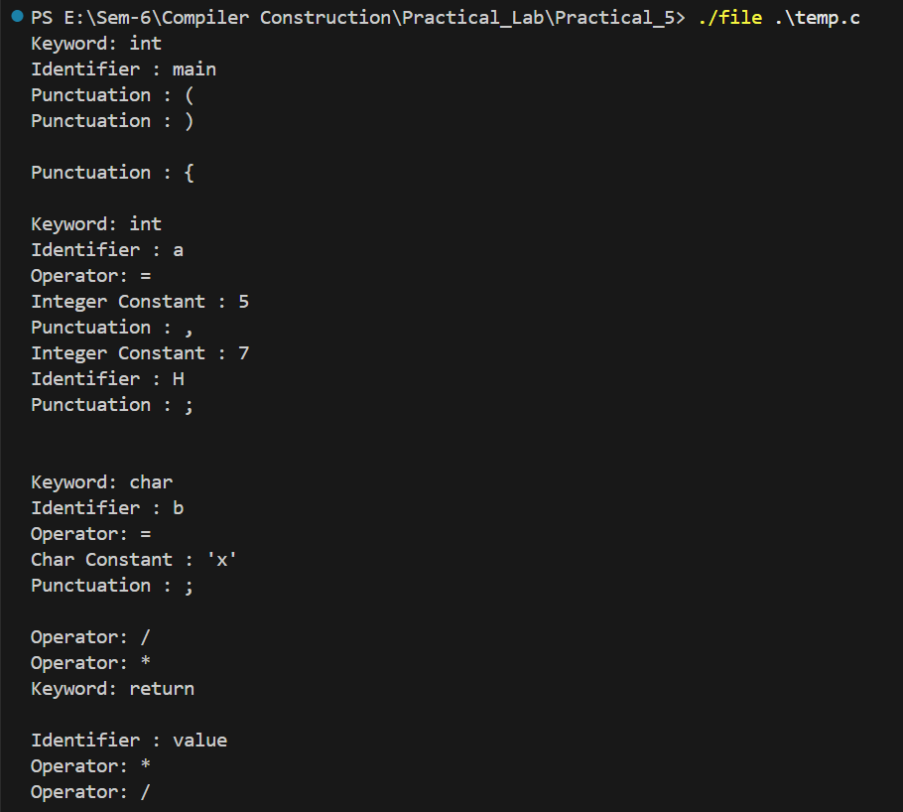

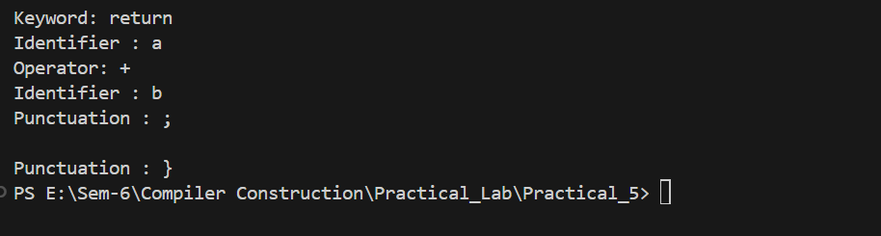

**Conclusion:**